1)Clickable Image(inside a tag put img tag)

<a href="https://www.w3schools.com">
<img border="0" alt="W3Schools" src="logo_w3s.gif" width="100" height="100">
</a>

2) Create horizontal navbar with ul(Give li inside ul display property of inline or inline-block)

eg -
<style>
ul {
list-style-type: none;
margin: 0;
padding: 0;
}

ul a{
text-decoration:none;
}

li {
display: inline-block;
}
</style>
</head>
<body>

<ul>
<li><a href="#home">Home</a></li>
<li><a href="#news">News</a></li>
<li><a href="#contact">Contact</a></li>
<li><a href="#about">About</a></li>
</ul>

</body>

3)Parallex effect(only background attachment is a change)

.main-tastebuds{
background: url('bg2.jpg');
background-size: cover;
padding-top: 5rem;
padding-bottom: 5rem;
color: #fff;
background-attachment: fixed;
}

4)Golden contact form
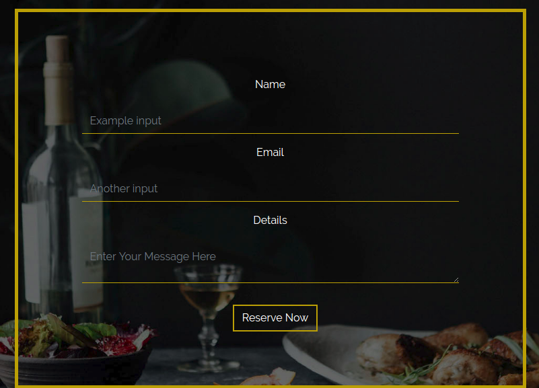

html -

<div class="container-fluid reservation-box text-center">
<div class="container">
<div class="row justify-content-center">
<form class="col-md-8">
<div class="form-group justify-content-center">
<label for="formGroupExampleInput">Name</label>
<input type="text" class="form-control" id="formGroupExampleInput" placeholder="Example input">
</div>
<div class="form-group">
<label for="formGroupExampleInput2">Email</label>
<input type="email" class="form-control" id="formGroupExampleInput2" placeholder="Another input">
</div>
<div class="form-group">
<label for="formGroupExampleInput2">Details</label>
<textarea class="form-control" id="formGroupExampleInput2" placeholder="Enter Your Message Here"></textarea>
</div>
</form>
</div>
</div>

</div>

Css-

/* Reservations */
.reservation-box {
background: url('reservations-bg.jpg');
background-size: cover;
background-position: center;
background-attachment: fixed;
padding: 5rem 0 5rem 0;
color: #fff;
}

.reservation-box a {
margin-top: 2rem;
}

.reservation-box img {
padding-bottom: 2rem;
}

form {
border:5px solid #bb9f05;
padding: 5rem;
}

.form-control {
display: block;
width: 100%;
padding: .5rem .75rem;
font-size: 1rem;
line-height: 1.25;
color: #464a4c;
background-color: transparent;
background-image: none;
border-bottom:1px solid hsl(51,95%,38%) !important;
border: none;
border-radius: 0px;

}

.form-group {
margin: 0 5rem;
}

label {
padding-top: 1rem;
padding-bottom: 1rem;
}

5) Hero Text

.hero-text {
position: absolute;
top: 50%;
right: 50%;
transform: translate(50%,-50%);
text-align: center;
}

